CLO 02: Comprehend the advantages of consistent and reliable web application design.
Q1: Design the Page using HTML. [Marks: 06]
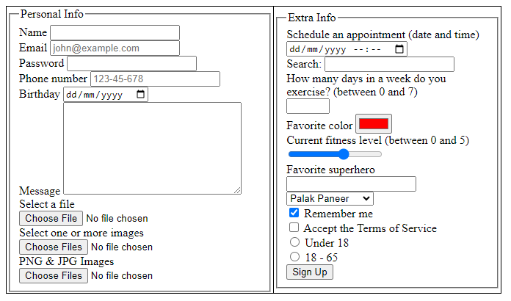

CLO 01: Understand the role of design and its major activities within the web development process, with focus on the w3c standards.
Q2: Design the below structure using bootstrap grid layout. [Marks: 03]

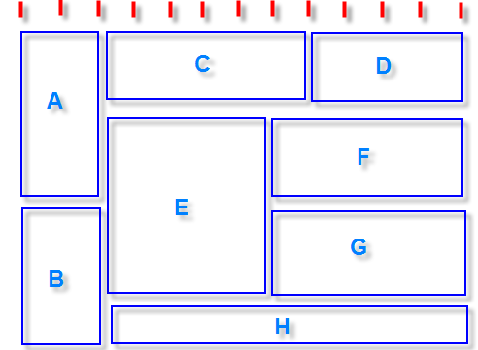

CLO 04: Apply Frameworks to develop engineering solution
Q3: Write necessary JavaScript code for the problem given below. [Marks: 06]

Dynamic Div Styling: Design a page with an initially visible div element (<div id="myDiv">) that displays some text. Users should be able to change the background color of this div by selecting options from a dropdown menu labeled "Choose a color." Additionally, they should be able to adjust the width and height of the div by selecting options from another dropdown menu labeled "Choose a size." These changes should be reflected in real-time upon selection.
Toggle Visibility: Implement a button labeled "Toggle Visibility" that, when clicked, smoothly fades the div in and out. Clicking the button again should restore the div to its previous state of visibility.
Requirements:
Use HTML to structure the page.
Employ CSS for basic styling, ensuring readability and clarity.
Utilize JavaScript and the Document Object Model (DOM) to handle user interactions and dynamically update the page content

